Dear Lending Partners,
In response to the current Coronavirus (COVID-19) pandemic, we want to remind you of California Coastal Rural Development Corporation’s (Cal Coastal) loan and technical assistance programs to help support your small business and agricultural clients through this difficult time.

For more information about Cal Coastal’s loan programs, visit our website at: https://www.calcoastal.org/loan-programs/ For more information about our Small Business Development Center, see: https://calcoastalsbdc.com/.

Also, if you have existing clients that were financed under the California Small Business Loan Guarantee Program that are experiencing temporary cash flow issues due to the negative economic impacts of the Coronavirus, Cal Coastal will consider your requests to defer their loan payments for a stated period of time. Under this same program, we also administer a Disaster Relief Loan Guarantee Program as outlined below. This Program can be used to provide interim financing, to support a line of credit, or a term loan.
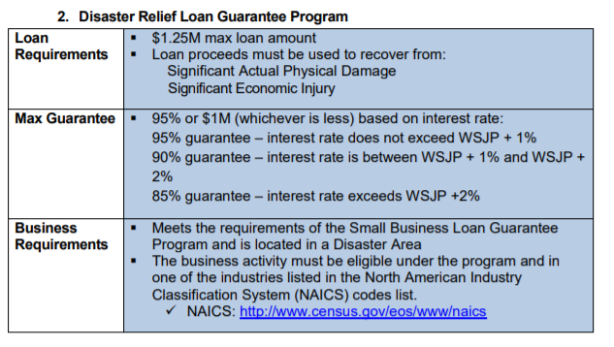
FOR MORE INFORMATION, PLEASE CALL CAL COASTAL AT 831-424-1099

This is an uncertain time and our country is facing an unprecedented crisis. Together, we can work together and protect our families and communities. We hope Cal Coastal’s programs and services can be utilized to assist you or your client’s financing needs.

Be safe and stay healthy!

Lee T. Takikawa, President & CEO

